**Beam Search**

B – Beam width

In greedy search it would only look after one likely word that can match where as in beam search it searches for more likely word given beam width

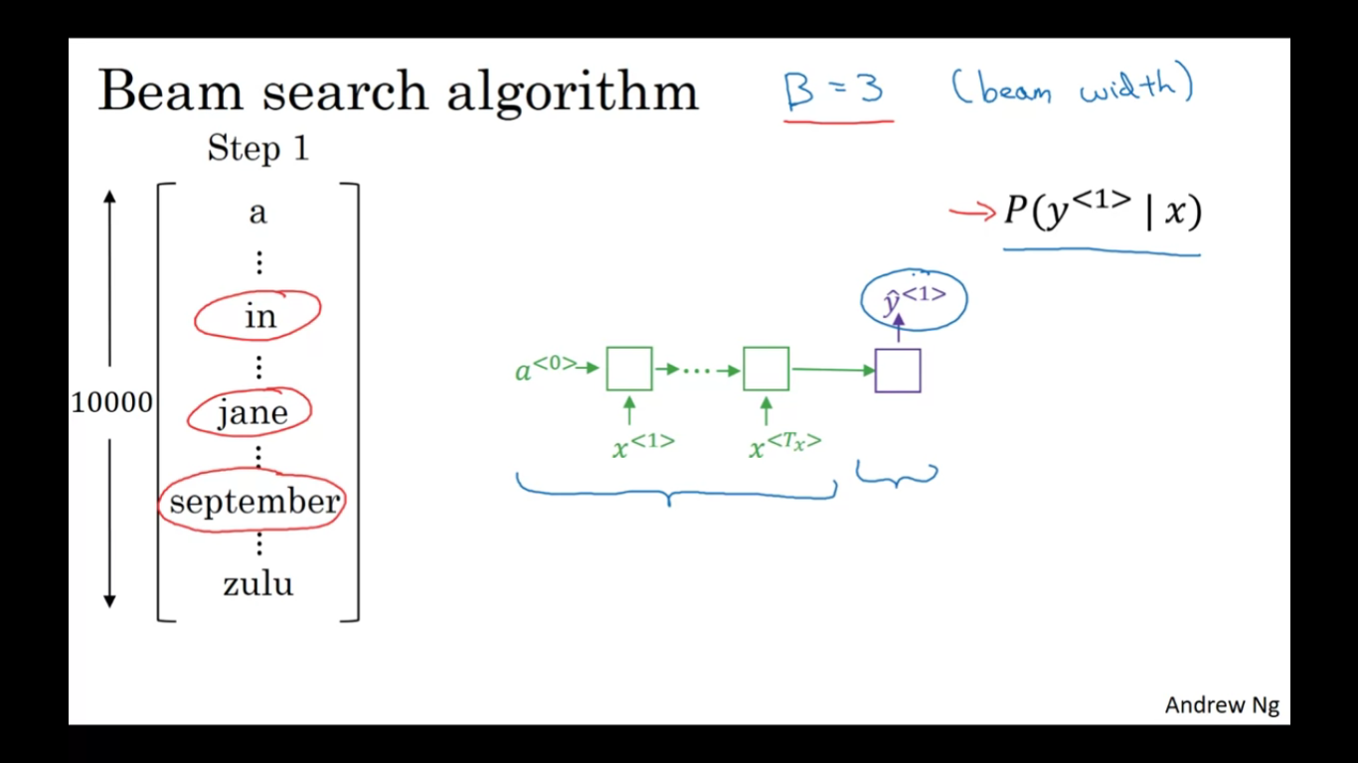

After first step then the beam search would search for the most likely second word from the dictionary or vocabulary

As we are considering beam width as 3 we need to evaluate 3 * 10000 times(beam width * vocabulary size)

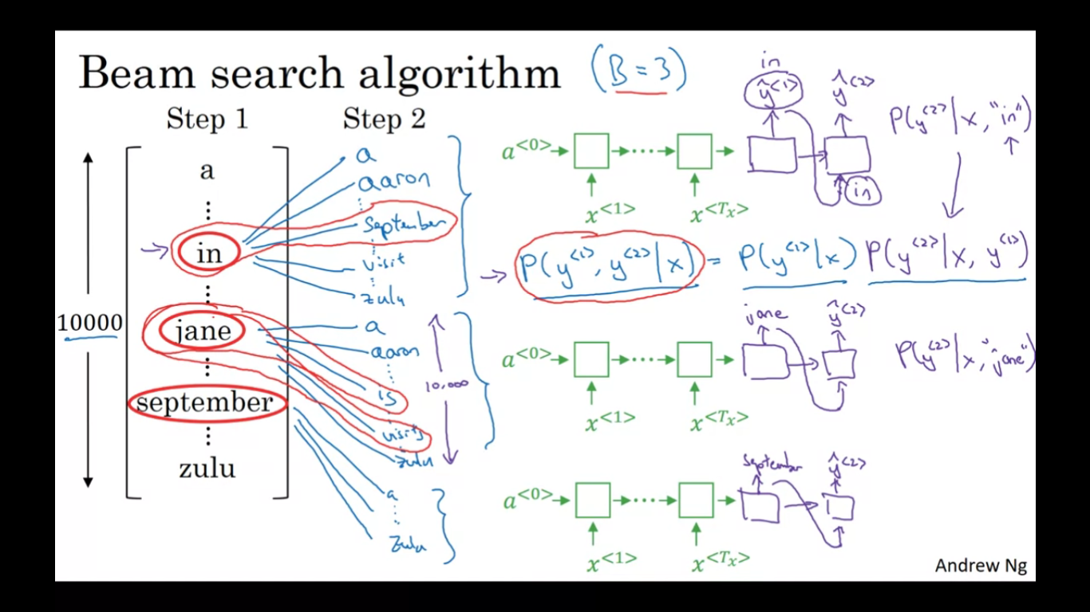

If beam search consider the 3 most likely words as ‘in september’, ‘jane is’ and ‘jane visits’ it rejects the sepetember from the first step. So there are two possibilities and 3 choices

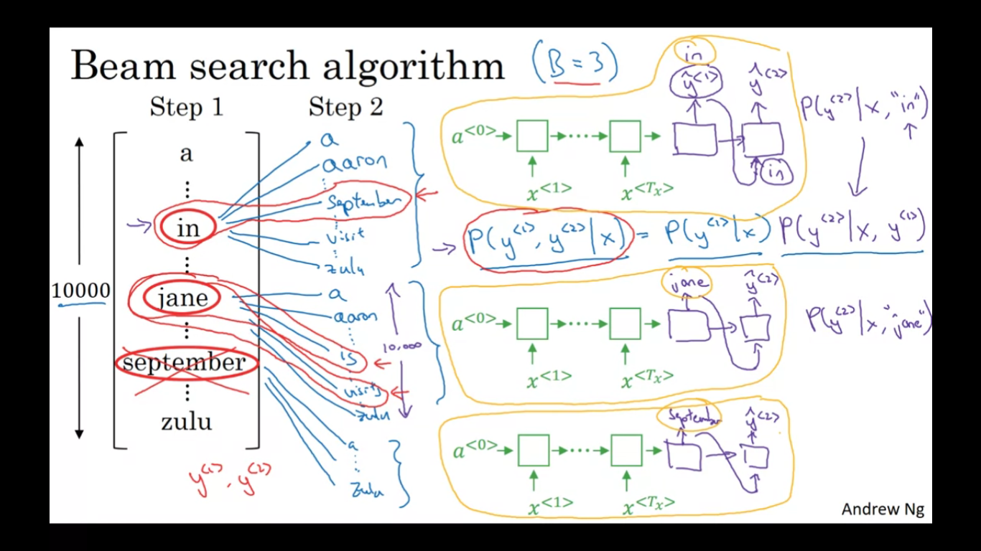

Step 3:

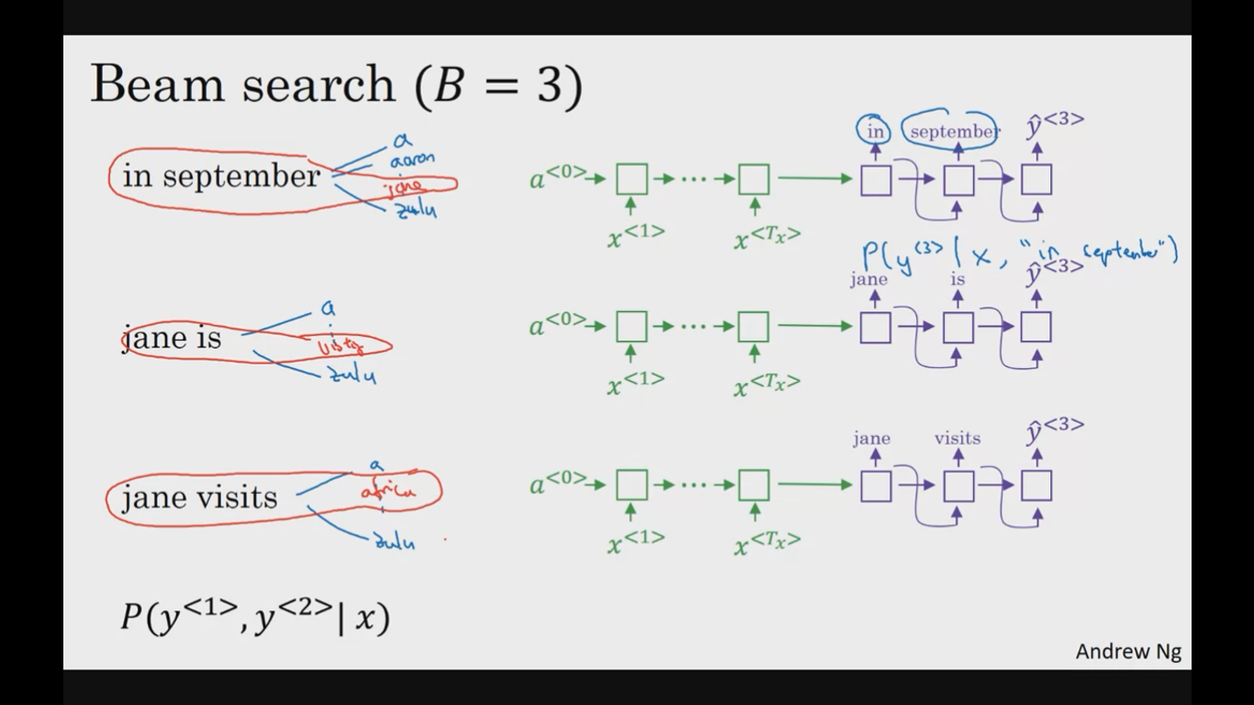

steps goes on till it will find the sentence

